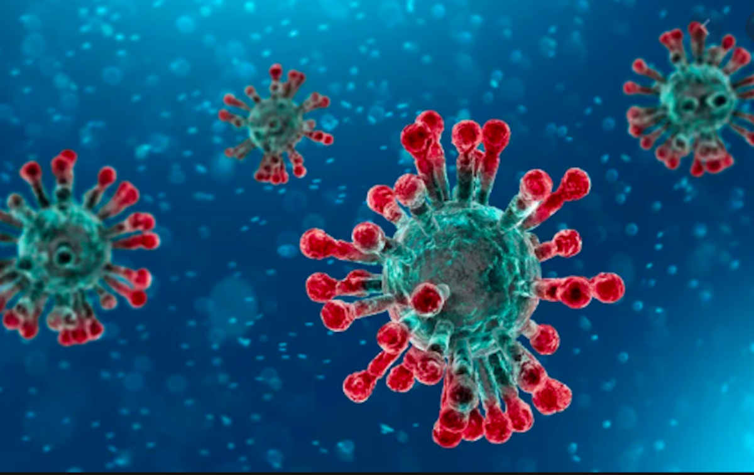  - MCA & MCS- Sponsored Virtual Meeting!  January 19 & February 2, 2021  Part 1:  Advanced Strategies for Gut Health: Infections, Parasites, and Stealth Pathogens  Course goals  - Overview of the common causes of gut inflammation/permeability with a focus on infections, stealth pathogens and parasites  - Develop appropriate nutritional, diet, lifestyle, and herbal protocols for every case  Learning objectives/learning outcomes  On completion of this course, attendees will have the:  - Basic clinical understanding of the impact infections, parasites, and stealth pathogens have on gut health  - Understand how to properly assess and provide nutritional, herbal, dietary, and lifestyle support for the prevention and support of gut infections, including stealth infections and parasites | 2 Part Virtual Meeting!  ____  January 19 & February 2 7:00 pm – 9:00pm  ____  Co-Sponsored by NENS & SPNN (Standard Process)  ____  4 CEU’s Credits are applied for all New England States thru TCC. 4 PDA points for New England States have been applied for through NCCAOM.  **Must attend all 4 hours to receive credits  ____  To Register:  Healthcare Professionals:  Non-credit/Staff/Student/Spouse:

Part 2: An Integrative Approach to Gut Health

Course goals
- Overview of the common causes of gut inflammation/permeability with a focus on gut dysbiosis
- Develop appropriate nutritional, diet, lifestyle, and herbal protocols for every case

Learning objectives/learning outcomes
On completion of this course, attendees will have:
- Current medical understanding of gut inflammation/permeability and its causes
- Understand how to properly assess and provide nutritional, herbal, dietary, and lifestyle support for the prevention and support of gut dysbiosis and gut inflammation/permeability

Speaker: Dr. Bob Scott
Dr. Scott has served as a clinical consultant to health care practitioners since 2007. He offers educational seminars, teleconferences, and webinars throughout New England. He is a graduate of the University of Bridgeport with a Doctorate of Naturopathic Medicine and a Masters in both Human Nutrition and Acupuncture. Dr. Scott served as an assistant professor, lab coordinator, and pharmacy director for the University of Bridgeport College of Naturopathic Medicine. Dr. Scott maintains a private practice where he focuses on drug free hormone balancing for both women, thyroid and adrenal health, and detoxification.

3545454ngreen@spnens.com

